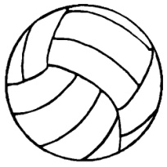
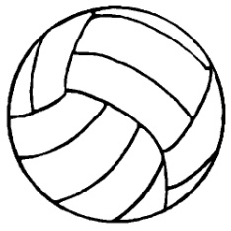
Volleyball Study Guide
History
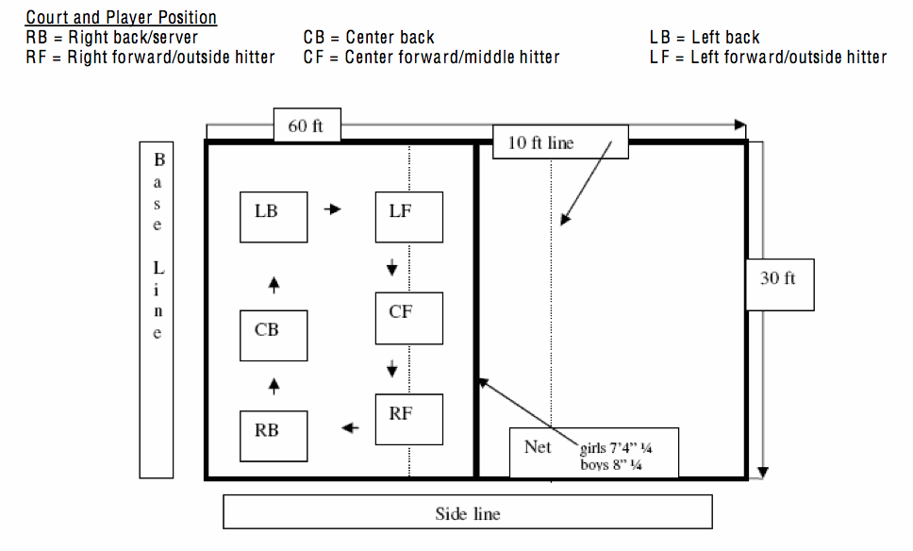
YMCA Director William G. Morgan developed the game of volleyball in 1895 in Holyoke, Massachusetts. It was developed as a recreational activity for businessmen who wanted a game with less physical contact than basketball. Morgan originally called it “mintonette.” Dr. George Fisher is known as the father of volleyball where it was introduced into the Olympic Games in Tokyo in 1964. In 1984, the US men won their first Olympic Gold Medal in Volleyball.
Court and Player Positions
Game
Volleyball is a game played by 2 teams of 6 players, each on a rectangular court separated into two areas by a net. One team serves the ball over the net, trying to make it land on the opponent’s playing area. The receiving team shall return the ball over the net in a manner that it should land in the opponent is playing area. Every time the ball hits the floor, a point is scored. This method of scoring is known as rally scoring.
Scoring
Rally scoring is when the serving team wins a rally, they score a point. When the receiving team wins a rally, they gain a point and the right to serve. Games (sets) are played to 25 points with a minimum two-point advantage to win the set. Winning 2 out of 3 sets completes the match.
Etiquette
Announce the score before each serve
Roll the ball under the net when returning it to the server
Do not kick the volleyball
Never roll the ball under the net if someone is jumping
Don’t punch the ball or throw it if you lose the point
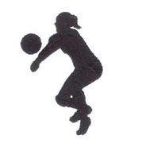
Don’t hit the ball after the whistle blows
Skills in Volleyball
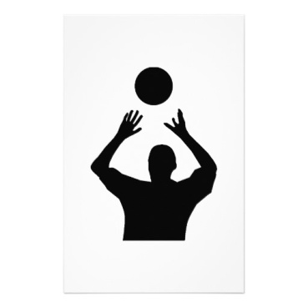
Forearm Pass- Method of passing the ball by bouncing it off both forearms. Commonly used for serve receive, passing a hard spiked ball, or passing a ball lower than the nose or away from the middle of the player’s body. Usually the first hit by the receiving team.
Dig- Passing of a powerfully spiked or hit ball. The back row players are responsible for digging the ball and keeping it in play.
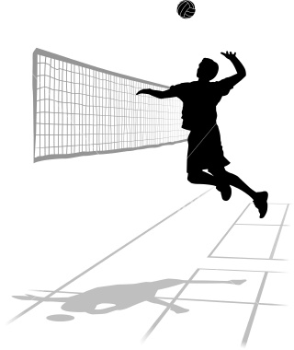
Set/Overhead pass- Overhand technique of putting the ball into the air close to the net for the spike. Usually the second hit after the forearm pass.
Spike- Striking the ball with the hand above net height to send the ball forcefully downward into the opponent’s court. This is the ideal third hit in a series. “BUMP, SET, SPIKE.”
Serve- Method of putting the ball in play (from behind the end line of the court.) The serve must be made from within a service area from right side line to the left sideline. There are three types of serves: underhand, sidearm, and overhand. The underhand serve is the easiest to master and is used by beginners. The sidearm serve can be useful if you want lower trajectory and can put spin on the ball. The overhand serve is the type most commonly seen and is very powerful and most difficult to receive.
Basic Rules
- Let serve- If the ball is served and makes contact with the net but reaches the opposing team’s side the ball is considered in play.
- A player may not hit the ball two times in a row. The only exception is if a player attempts to block and touches the ball, then they may play the next ball.
- A team may only touch the ball three times before it is sent over the net.
- There are six players on each team on the court at a time.
- A net violation occurs when any player comes in contact with the net or any part of the body while the ball is in play. When spiking the ball, the spiker’s follow-through may NOT contact the net.
- Players from the back row are allowed to spike the volleyball; however, they have to jump from behind the 10-foot line (spiking line.)
- Line/Court Rules
  - A ball is considered in bounds if any part of the ball is touching the side or the end line.
  - A player may step on the centerline but may not completely cross the line.
  - When serving, a player may not step on or over the end line until after contact has been made.
  - If the ball hits the antenna, it is considered out of bounds.
  - If the ball hits the ceiling and comes down on the opposing team’s court, it is considered out of bounds. However, if the ball contacts the ceiling and comes down on the same side of the net, the ball is playable.
- No player may contact the ball on the opponent’s side of the net, unless it is a block.
- Players rotate in a clockwise position.
- Blocking a served ball is NOT permitted, nor is attacking a served ball while the ball is directly over the net.
Terms
Ace- A serve which lands on the court for a point without being touched.
Back set- A set made over the head and behind the setter.
Floater- A serve that is softly hit with no spin that “floats” or wobbles in flight.
Let Serve- A legal serve that touches the net as it goes over and lands in bounds.
Hit- Another name for a spike.
Hitter- The player who spikes the ball.
Kill- A non-returnable hit by a player.
Dink- A one-handed, soft hit into the opponent’s court using the fingertips.
Legal Hit- Contact with the ball by a player’s body above the waist, and in which the ball does not visibly come to rest.
Illegal Hit- Any hit below the waist, or if the ball visibly comes to rest momentarily on any part of the body.
Carry- When the ball rests momentarily on one or both hands.
Double hit- If one player hits the ball more than once consecutively, or can be uneven contact.
Foul- An infraction of the rules.
Foot Fault- Server steps on or over the end line before they have come into contact with the ball.
Net Recovery- AN attempt to play a ball that has been hit into the net.
Rotation- Act of shifting positions in a clockwise direction.
Side out- When the serving team violates a rule or hits the ball out.
Dead ball- Ball that is temporally out of play.
Point- Scoring unit awarded for an infringement of any rule by opposing team.
Match- The varsity match winner is the team who wins 3 out of 5 or 2 out of 3 sets.
