Soccer Study Guide
History
The Greeks plays the first form of soccer called Harpston, which means to “propel forward.” The Greeks played by throwing the ball. The game was sent to England where they began learning to kick the ball or strike with the hands. This game was a military sport for the training of warriors. The name Futbol was attached because of the use of the feet in advancing the ball.
Soccer as we now know it started on October 26, 1863, when 11 London amateur football guys met and former the London Football Association. Some form of soccer was played in American Colleges as early as 1830. Soccer is played in more than 55 countries.

General Description
Soccer is played on a rectangular field with two teams of 11 players each. The purpose is to make a goal into the net, as well as, defending your goal. The ball can be played off any part of your body except the hands and arms, but mostly by kicking. Each goal is worth 1 point. Most games are played with two halves each 40 minutes long.

Player Positions
Goalie/Goalkeeper- They protect the goal and prevent the opponents from scoring. This is the only player that can use their hands in the penalty area. In the penalty area they can throw, kick, punt or pick up the ball. Outside the penalty area they no longer have goalie privileges.
Forwards/Strikers- These players kick the ball on offense who is trying to score.
Midfielders/Halfbacks- Players on back offense and defense, but they play in the midfield area on both sides of the centerline. They control the flow and speed of the game.
Defenders/Fullbacks- These players help to guard the goal area.

Soccer Skills and Terminology
Dribbling- Short taps on the ball, to advance the ball to another by a single player.
Passing- A kick (or heading) used to get the ball to an open teammate.
Trapping- Used to stop or control the ball with your feet.
Shooting- Kicking or heading the ball toward the goal for a score.
Throw-in- A method of restarting play after the ball has traveled outside the touchlines.
Heading- When using your forehead to pass, to score, or to bring the ball to ground level.
Tackling- Used to get the ball from an opponent, to steal the ball.
Dodging- Used to keep control of evading an opponent.
Touchline- A side line or boundary line.
Fouls- When a player runs into, charges, pushes, kicks, trips, or holds a player.
Game Play Situations
Kick-off-Used to start the game or restart after a goal ball is kicked at midfield. The ball must make one revolution before anyone can touch it. Opposing players have to stay 10 yards from the kicker on kick-off. A goal cannot be scored off a kick-off.
Direct Free Kick- Taken from the point of violation unless in penalty area. You can score from this kick and everyone else must be 10 yards away. Violations include touching the ball, holding, pushing, kicking, kneeing, tripping, and charging.
Indirect Free Kick- Awarded to the other team as a minor foul (interfering with goalkeeper, goalkeeper delays, dangerous play.) A goal cannot be scored unless the ball has been played or touched by another player.
Penalty Kick- This is awarded to the offensive team when defense commits a foul in penalty area. It is taken from penalty spot 12 yards from goal line, only the goalkeeper defends against it.
Throw in- This is taken when the ball goes over the sideline. Each foot has to be on the ground and they can touch the line but not go completely over it.
Corner Kick - A corner kick is awarded to the attacking team if the ball crossed the goal line (but not in the goal) having been last played by a member of the defending team. It is taken from the corner of the field and all opponents must remain 10 yards away.
Goal Kick- Kick awarded to the defending team when the ball crossed their goal line, (not going in the goal) after been touched by an attacking team member. A player of the defending side, including the goalkeeper, may take the kick. Ball is placed within the half of the goal area nearer to the point where it crossed the goal line. Kicker must send the ball out of the penalty area and may not touch it until another player has played it. All opponents must stay outside the penalty area.
Goalie Ball – When the goalie stops and gathers the ball before it goes over the goal line, the goalies may drop kick or throw the ball back into play. The goalie may use his hands only in the penalty area and is allowed to take 6 seconds while holding the ball.
Drop Ball – A ball the referee drops between two players, one from each team, to restart play.
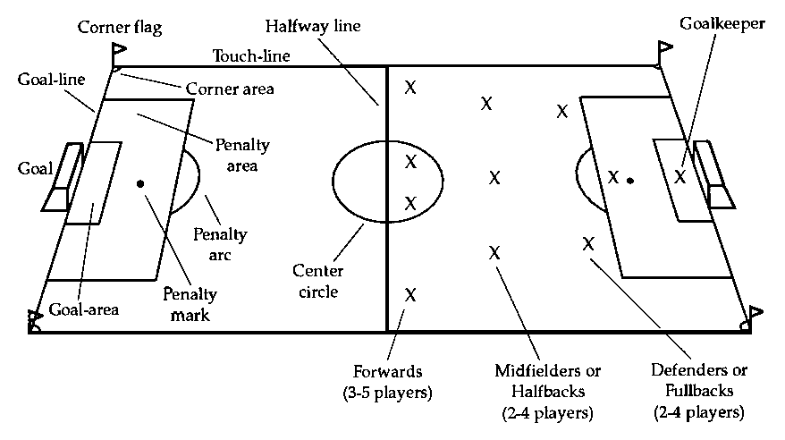
Field
Of
Play

